Van der **Pol** Equation

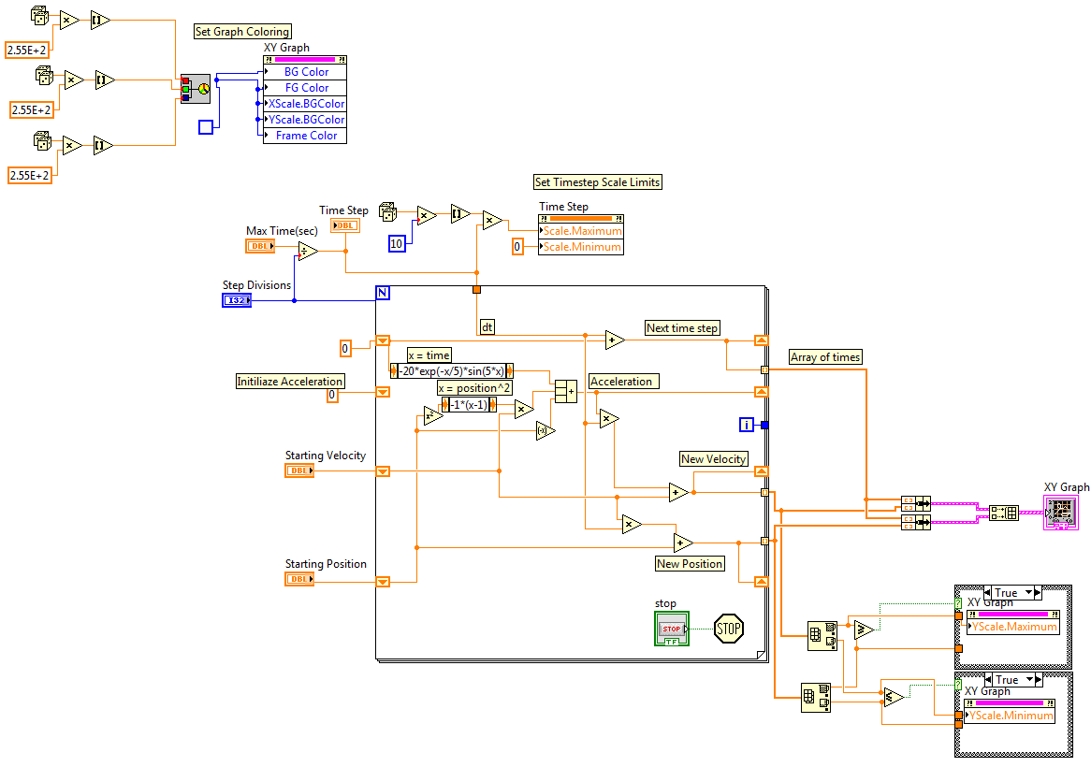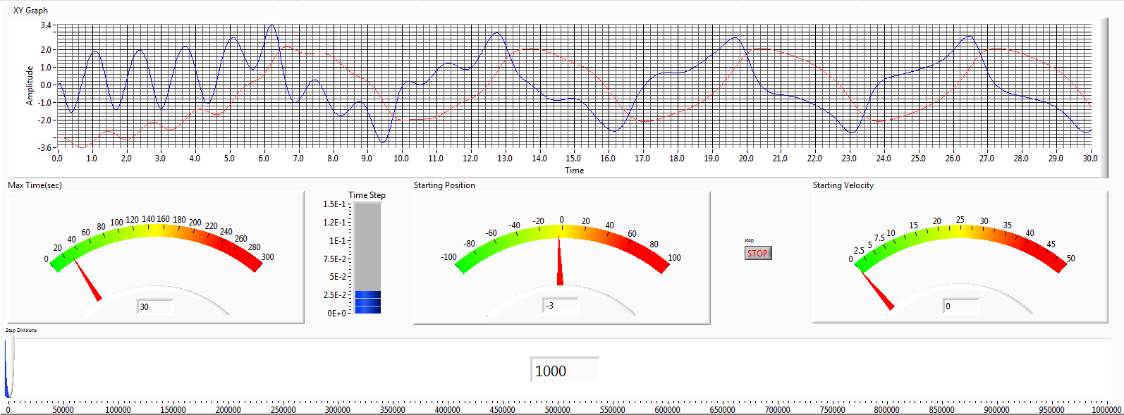 The van der pol equation with a forcing function has been evaluated using Labview. The user has inputs for the number of time steps, the starting position, and the velocity. The graph has been programmed to automatically adjust the range to the maximum and minimum along the y, and the programming eliminates wasted space. The velocity and position have been solved for using Numerical Integeration.